Lab 3 – Windows 2008r2 WSUS

For this lab

Discuss:
- What are the prerequisites of WSUS? Why are they needed?
- Any problems you had with the lab and what was done to fix the issues (even if the instructor fixed the issue. Pay attention!)
- Improvements you would make to the lab (Two minimum)

Questions to answer
- Why would you want to store WSUS updates locally?
- What reason would you have to not release updates to client computers?
- Why would you want to release updates to some computers but not others?

Figures to include
- Screenshot of prerequisite roles installed on Windows 2008 server.
- Screenshot of the WSUS install screen.
- Screenshot of domain machines appearing as a clients in WSUS
- Screenshot of the Windows 7 machine indicating there are available updates.
- Screenshot of the WSUS server indicating the needed but unapproved updates.
- Screenshot of the WSUS server indicating all machines are up to date.

Other things to include
The contents of the unattend.txt file you created in 10-point Currier new font, with paragraph shading of White, Background 1, Darker 15% for the contents of the file (See the screenshot for paragraph formatting help and the second paragraph for an example). DO NOT USE A SCREEN SHOT!
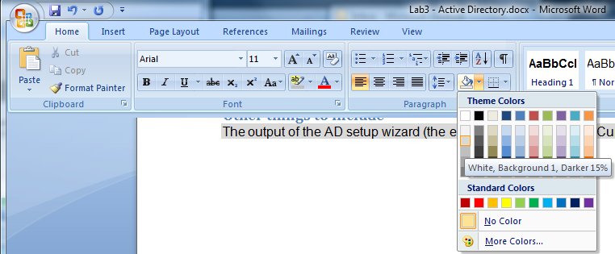
How to shade the contents of the unattend.txt file

[DCInstall]
ReplicaOrNewDomain=blah
NewDomain=blah.blah
NewDomainDNSName=who.knows
ForestLevel=16
DomainNetbiosName=bob
DomainLevel=4026
SafeModeAdminPassword=lassie
Example output from unattend.txt file

NOTE: the commands in this lab can be easily miss-typed. Pay careful attention to the commands and make sure they are successful before continuing!

Pre-lab
- Purge previous labs. Redeploy all three virtual machines with the following changes:
  - Make sure to delete and re-create the virtual NICs. We will not be using virtual fencing in this lab.
  - The memory settings should be changed: DC should be set to 512, Client should be set to 768, Server should be set to 768.
  - Uncheck start virtual machines on completion.
  - See http://www.carybarker.com/Lab Manager Deployment/Lab Manager deployment.html for details.
- Download (NOT INSTALL!) the WSUS 3.0 SP2 install files (WSUS30-KB972455-x64.exe) and the Microsoft Report Viewer Redistributable 2008 (http://www.microsoft.com/downloads/details.aspx?FamilyID=cc96c246-61e5-4d9e-bb5f-416d75a1b9ef&displaylang=en) on the 2008 full install server FIRST. You may not be able to get to the internet after changing DNS.
  - To fix IE security to allow the download:
    - Go into server manager. Under Security Information, click on Configure IE ESC.
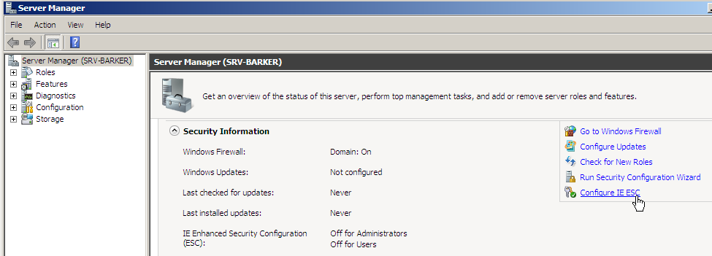
    - Click on the Off radio buttons. Click on OK.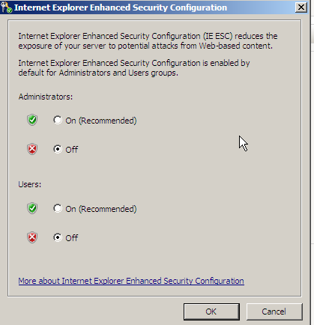

- You need all three machines for this lab: AD server, Windows 7 machine and 2008r2 full install Server. The names should be set as follows:
  - DC name: DC-LastName
  - Windows 7 PC name: CL-Lastname
  - 2008 full install name: SRV-LastName
  - Domain name: lastname.internal
- You do not change IP addresses for this lab. However, you do still need to properly disable IPv6 and set the DNS servers for all computers to the IP address of your windows CORE (DC) server. (Remember, the CORE domain controller must be set up before you configure the other computers. When you set the DNS IP address on the CORE server, it will complain – this is expected.)
- Set up a Windows 2008 Domain Controller, install Active Directory, Create and join a Windows 7 PC to the domain, configure the CORE machine for remote management (firewall) Install RSAT. DO NOT CHANGE IP ADDRESSES ON THESE SYSTEMS – YOU NEED TO BE ABLE TO GET TO THE INTERNET FOR UPDATES.
- Add 65.111.80.9 as a DNS forwarder to the domain after you have run dcpromo:
  - On the Windows 7 machine, log in with a Domain Administrator account.
  - Open up DNS Manager
  - Connect to the Domain Controller (DC-lastname)
  - Right-click on the server and select Properties
  - Click on the Forwarders tab.
  - Click on Edit
  - Type in the IP address of the forwarder(s) – specifically 65.111.80.9
  - Click on OK twice.
  - Close DNS Manager
- Also make sure to add a Windows 2008 Server (full install) to the network. Make sure the system can ping the AD server.

On the Windows 2008 full install machine
Follow the instructions for installing a WSUS server at: http://www.microsoft.com/downloads/details.aspx?FamilyID=df628245-8449-4b93-948c-0926deb1197a&displaylang=en
When installing WSUS:
- Step 0: (not in the instructions). Install Microsoft Report Viewer Redistributable 2008 (http://www.microsoft.com/downloads/details.aspx?FamilyID=cc96c246-61e5-4d9e-bb5f-416d75a1b9ef&displaylang=en) .
- Step 1:
  - Be careful to install all the dependencies exactly as specified in the Microsoft document (p6 & 7). Be especially careful of the IIS sub-dependencies. If asked by the wizard, accept installing other dependencies.
  - Take a screenshot of the roles (from Server Manager) you have installed before you run the WSUS setup. Include this screenshot in your lab report.
- Step 2:
  - When performing the WSUS setup, make sure to do the Full server installation including Administration Console; do not do the console only install.
  - Uncheck “Store updates locally”. If you fail to do this your computer will download tons of updates and fill your hard drive.
  - For database options, choose “install Windows Internal Database on this computer”. Leave the default location.
  - On the Web Site selection page, leave the default “Use the existing IIS Default Web site.”
  - Take a screenshot of the Ready to Install Windows Server Update Services 3.0 SP2 page and include it in your lab report.
- Step 3:
  - There are no firewalls or proxies that would prevent WSUS from getting to the internet.
  - Uncheck Yes, I would like to join the Microsoft Update Improvement Program.
  - Synchronize from Microsoft Update.
  - No Proxy server
  - After clicking on “Start Connecting” you will wait a while.
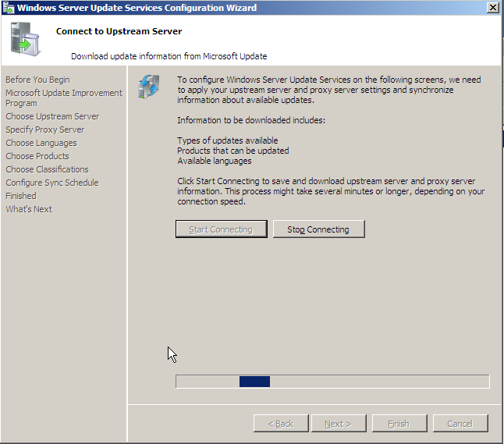
This took about 5 min – not too bad.
- Step 4:
  - Update language is English (you shouldn’t even see this page, but just in case. . . ).
  - Obtain updates for Windows 2008, 2008 R2 and Windows 7 ONLY.
  - Select Critical Updates, Definition Updates, Security Updates, Update Rollups, and Updates
  - Update Schedule should be set to manual.
  - Leave Launch the Windows Server Update Services Administration Console and Begin initial synchronization checked.
- Step 5:
  - Configure the Default Domain Policy (GPO) to enable automatic updates and “Auto Download and Notify for Install”.
  - Also point the client computers to your WSUS server for their updates.
  - Once you have configured group policy, run gpupdate /force on your Windows 7 client computer. Also run wuauclt.exe /detectnow. Check your WSUS console for the computer to make sure it shows up. (If that doesn’t work, try a manual detection to move things along)
NOTE: when looking at available updates/computers/whatever in the Update Services console, make sure to select “ANY” from the middle pane. If you leave the default, nothing will show up!
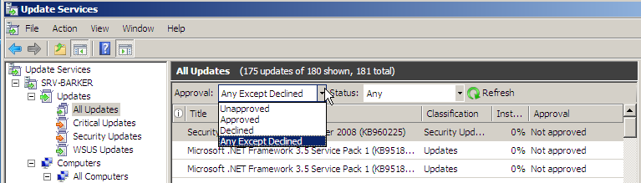
- Step 6: Move your Windows 7 client computer to the test group you create.
  - Take a screenshot showing ALL the computers in the domain (before you assign them to any groups) – You may need to run gpupdate /force or other commands to make this happen.
- Step 7:
  - Find updates that apply to your computers:
    - Go to All updates. Select Approval: Unapproved and Status: Needed.
    - Take a screenshot of the updates that are needed but unapproved. Include this in your lab report.
  - Approve and deploy updates to your Windows 7 ‘test’ group.
  - Check the status of the update, then go to the Windows 7 computer and install the update (you should be prompted).
  - After installing and rebooting, check the status again on the WSUS server. Take a screenshot and include as the final status on your lab report.

LAB 3 Evaluation Criteria

NAME: ____________________________

COMPONENT | POINTS |  | POINTS EARNED | COMMENTS
Overall look and feel
Title Page | 3 |  |  | Title page neat, clean, includes lab # and lab title, Student’s name, date, e-mail address, class and section number are included.
Table of Contents | 2
Executive Summary | 5
Professional Appearance | 5 |  |  | Professional overall look, font etc – readability spelling and grammar
Header | 2 |  |  | – Lab Title
Footer | 2 |  |  | – page, course # and student name
Section Headings | 2
Numbered & Labeled Figures | 2 |  |  | Tables, Diagrams, Screenshots etc labeled and numbered
Numbered Pages | 2
Content
Body Content | 5 |  |  | Clear and well organized point by point description of the actions taken  Each component should have its own section.
Tables/Diagrams | 5 |  |  | Any tables and diagrams in 10-point Currier new font, with paragraph shading of White, Background 1, Darker 15% . A description must follow each table or diagram, detailing what was going on and why.
System Configuration/Reports
Proper function of  Windows Vista  Windows 2008 | 10 |  |  | The following configuration is in place:  System is functioning as it should at the end of the lab – Windows 7 can get list of approved updates from WSUS server, WSUS server properly reporting, etc.
Questions/Discussion addresses issues brought up in the Lab | 15 |  |  | Systems are properly configured:  - Screenshots included  - WSUS installed correctly  - GPO created properly  - Updates stored at MS, not locally  - Updates approved are getting installed  - All domain computers appearing in WSUS
Total: | 60

